Call for Abstracts

The first ISO-FOOD International Symposium on Isotopic and Other Techniques in Food Safety and Quality
Piran, Slovenia, from April 1-3, 2019.

Dear Colleague,

We are pleased to announce that the first ISO-FOOD International Conference on Isotopic and Other techniques in Food Safety and Quality. Preparations are finished, awaiting April 1st, 2019.
This is the open call for abstracts to the first ISO-FOOD conference that will be held next to the historic coastal town of Piran, Slovenian from April 1-3, 2019. The conference is organised by ISO-FOOD ERA Chair, Department of Environmental Sciences at the Jožef Stefan Institute, Ljubljana Slovenia. http://iso-food.academicevent.net
Conference Program: This symposium welcomes researchers, scientists, experts, stakeholders to present and share knowledge, experiences, new advances and research results. We invite you to submit original abstracts in relation on the following broad topics:

Food authenticity and traceability Food databases and semantics
Food safety and quality Advanced materials and nanotechnologies
Metrology in food foodomics

On-line registration and abstract submission is open, so please do not send your abstracts and registrations by email, but submit them at http://iso-food.academicevent.net/call-for-abstracts/. We already have an impressive list of confirmed speakers: http://iso-food.academicevent.net/speakers/.

All the information you need is available on the conference website http://iso-food.academicevent.net/ or for any specific enquiries please do not hesitate to contact us directly at erachair@isofood.eu. We will publish new and update existing information regularly. The abstract submission deadline is February 1st.
We are looking forward to seeing you in Piran.
Best regards,

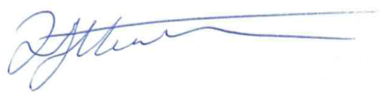

David Heath (On behalf of Symposium Organizing Committee)
ERA Chair ISO-FOOD
Department of Environmental Sciences
Jožef Stefan Institute
Ljubljana, 1000
Slovenia
erachair@isofood.eu

